**Reducing DON Concentration with Naked Barley**

Kevin P. Smith, Ed Schiefelbein, Guillermo Velasquez and Yanhong Dong

University of Minnesota, Saint Paul, MN

Corresponding Author: Kevin P. Smith, smith376@umn.edu

**Abstract**

A major concern with barley infected with *Fusarium graminearum* is the accumulation of the mycotoxin deoxynivalenol (DON). The hull of barley can account for a significant amount of the DON in Fusarium infected grain. Nearly all the barley in the U.S. is covered barley used for animal feed or by the malting and brewing industries. Loss of the hull during harvest as occurs with naked barley could be a way to mitigate the risk of DON contamination in the food chain. To explore this potential benefit, we developed near-isogenic lines (NILs) for the hulless trait. A total of 30 NILs for each class (naked and covered) were evaluated in an inoculated Fusarium head blight (FHB) nursery in 2021. The average concentration of the naked lines compared to the covered lines was 2.4 and 5.9, respectively. This constitutes a 59 % reduction in the DON concentration of the harvested grain. This reduction in DON is comparable to what is possible using a protective fungicide or by using a moderately resistant cultivar versus a susceptible one. It may also be possible to develop selection strategies that increase the amount of DON that accumulates in the hull relative to the kernel further reducing DON levels in the harvested naked grain. Breeding naked barley varieties with reduced DON and that can have multiple end uses could have a substantial impact on reducing the risk of DON contamination.

**Introduction**

A major concern with barley infected with *Fusarium graminearum* is the accumulation of the mycotoxin deoxynivalenol (DON). The hull of barley can account for a significant amount of the DON in Fusarium infected grain (Clear et al., 1997). Nearly all the barley in the U.S. is covered barley used for animal feed or by the malting and brewing industries. However, naked (or hulless) barley could have value for these uses in addition to direct use as human food (Meints et al, 2021). Loss of the hull during harvest as occurs with naked barley could be a way to mitigate the risk of DON contamination in the food chain. We used near-isogenic lines for the naked caryopsis phenotype to characterize DON concentration in naked and covered harvested grain.

**Materials and Methods**

We generated a bi-parental mapping population using the FHB susceptible parent Lacey and the moderately resistant and naked parent Hor211 (Sallam, 2005). The population consisted of 495 F6:8 lines that were phenotyped for the naked caryopsis trait, FHB severity, and DON. Five lines in the population were scored as segregating for *nud* and one (HLM-280) was selected to develop NILs. We selected 50 covered and 50 naked kernels from the segregating F6:8 seed lot of the line HLM-280 and grew them up to verify their caryopsis status and increase seed for screening in our FHB nursery (Figure 1). Thirty plants were selected as covered and thirty more were selected as naked and seed produced from these plants were planted in single row plots 1.2 M in length in our FHB nursery in Crookston, MN in 2021. These 60 entries along with the checks Lacey and Quest (replicated twice) were planted in a completely randomized design. Grain spawn inoculum and mist irrigating were used to promote disease. Plots were harvested at maturity, threshed, cleaned, and ground for DON analysis (Mirocha et al., 1998).

A

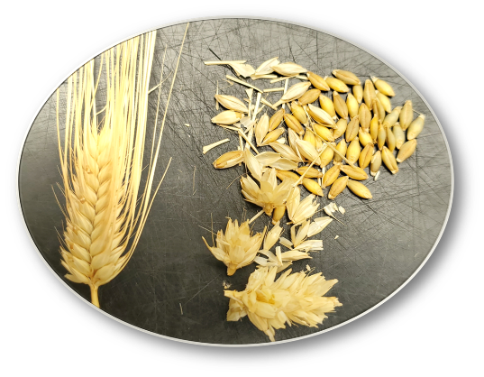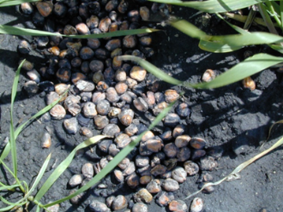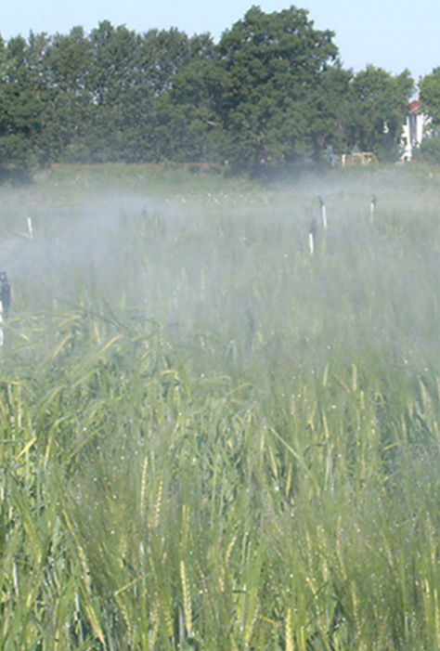

C

B

**Figure 1. A.** Spike of a naked barley line, B. grain spawn Fusarium inoculum, and C. mist irrigated Fusarium Head Blight nursery.

**Results**

The range of DON concentration for the covered NILs was 2.9 to 12.3 ppm and for the naked NILs was 1.0 to 4.4 ppm. The average DON concentration of the 30 covered and 30 naked barley NILs was 5.9 and 2.4 ppm, respectively (Figure 2). This represents an average reduction of DON concentration of 59%.

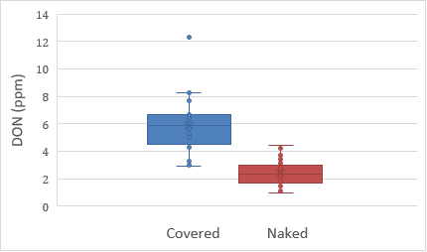

**Figure 2**. Comparison of 30 covered and 30 naked near-isogenic lines for naked and covered kernels derived from the cross between Hor211 and Lacey. The average DON concentration for the covered check variety Lacey was 4.6 ppm.

**Discussion**

Previous studies to determine the amount of DON that accumulates in the hull have based their estimates on mechanical removal of the hull through pearling (Clear et al., 1997). In this study we used segregating lines derived from a single F6 individual from a bi-parental mapping population of 495 lines. The probability of an F6 line being heterozygous at any one locus is 1.6% which in a population of 495 individual should be about eight. In our study we identified five. The F6 individual that we identified should be homozygous at 98.5% of the genome. This would suggest that the naked and covered progeny lines from this individual are indeed near-isogenic. We are genotyping these lines with the Barley 50K SNP to confirm that the lines differ at the *nud* locus and identify other loci that were heterozygous in the original F6 parent and would be segregating in its progeny.

Reducing DON concentration by 60% would have a substantial effect on reducing the risk to farmers. This advantage is already realized in wheat which threshes clean without hulls. Typical reduction of DON concentration in barley using fungicides is 30-50% (Cowger et al., 2019). Similarly, the amount of reduction in DON concentration between a susceptible and moderately susceptible variety is about 50 %. In another project we are using a naked barley diversity panel to characterize genetic variation for DON concentration in the kernel and hull. Using this panel for genome-wide association studies we have identified loci for these traits (Hawkins, 2022). Thus, it may be possible to breed to select for lines that accumulate more of the DON in the hull than in the kernel and improve the advantage of naked barley relative to covered barley.

The impact of this work will only be realized if naked barley varieties are developed that are adapted to production regions and have the properties of desired by end users (Massman et al., 2022; Meints and Hayes, 2019). A national project to develop mult-purpose naked barley for organic productions systems is exploring food, feed, and malting uses of naked barley (<https://eorganic.info/node/23562>). Vertical Malt, a craft malt company in Northern Minnesota has produced small amounts of malt from an advanced naked barley line from our breeding program for distribution to brewers for testing and evaluation. Increasing the footprint of naked barley production and use could be one way to reduce the entrance of DON into our food system.

**Acknowledgements**

This research was supported in part by USDA-OREI grants program 2017-51300-26809 and 2020-51300-32179 and USDA-ARS United States Wheat and Barley Scab Initiative. Any opinions, findings, conclusions, or recommendations expressed in this publication are those of the author(s) and do not necessarily reflect the view of the USDA.

**References**

Clear, R. M., Patrick, S. K., Nowicki, T., Gaba, D., Edney, M., & Babb, J. C. (1997). The effect of hull removal and pearling on Fusarium species and trichothecenes in hulless barley. *Canadian Journal of Plant Science*, *77*(1), 161–166. https://doi.org/10.4141/P96-014

Cowger, C., Arellano, C., Marshall, D., & Fitzgerald, J. (2019). Managing Fusarium Head Blight in Winter Barley With Cultivar Resistance and Fungicide. *Plant Disease*, *103*(8), 1858–1864. <https://doi.org/10.1094/PDIS-09-18-1582-RE>

Hawkins, John. (2022). Exploring Variation for Fusarium Head Blight Resistance and Deoxynivalenol Distribution in the Naked Barley Diversity Panel. Retrieved from the University of Minnesota Digital Conservancy, <https://hdl.handle.net/11299/241560>.

Massman, C., Meints, B., Hernandez, J., Kunze, K., Hayes, P.M., Sorrells, M.E., Smith, K.P., Dawson, J.C., Gutierrez, L. 2022. [Characterization of agronomic traits in organic spring naked barley.](https://doi.org/10.1002/csc2.20686) Crop Science. <https://doi.org/10.1002/csc2.20686>

Meints, B. and Hayes, P.M. (2019). Breeding Naked Barley for Food, Feed, and Malt. In Plant Breeding Reviews, I. Goldman (Ed.). <https://doi.org/10.1002/9781119616801.ch4>

Meints, B., Vallejos, C., & Hayes, P. (2021). Multi-use naked barley: A new frontier. Journal of Cereal Science, 102, 103370. <https://doi.org/https://doi.org/10.1016/j.jcs.2021.103370>

Mirocha, C. J., Kolaczkowski, E., Xie, W., Yu, H., & Jelen, H. (1998). Analysis of Deoxynivalenol and Its Derivatives (Batch and Single Kernel) Using Gas Chromatography/Mass Spectrometry. Journal of Agricultural and Food Chemistry, 46(4), 1414–1418. <https://doi.org/10.1021/jf970857o>

Sallam, A.H. 2005. Investigating the genetics of resistance to Fusarium head blight in six-rowed hulless barley accession HOR211. M.S. thesis, University of Minnesota, St. Paul.