**Pathogenicity of *Fusarium graminearum* and *F. poae* Causing Fusarium Head Blight in Barley Under Controlled Conditions**

K. Hudson, L. J. Harris, D. P. Overy, A. Xue, A. Foster, R. Khanal*. Ottawa Research and Development Centre, Agriculture and Agri-Food Canada, 960 Carling Ave, Ottawa, ON K1A 0C6, Canada; (A.F.) Charlottetown Research and Development Centre, Agriculture and Agri-Food Canada, 400 University Avenue, Charlottetown, PE C1A 4N6, Canada*

**ABSTRACT**

Fusarium head blight (FHB) is one of the most devastating diseases of barley. FHB is caused by a species complex of *Fusaria*, of which *Fusarium graminearum* is the species responsible for most FHB epidemics in Canada. Field surveys show that two or more *Fusarium* species often co-exist within the same field or grain sample and *F. poae* is reported as another dominant species in barley in eastern Canada. The aim of this study was to determine the pathogenicity of *F. graminearum*, *F. poae* and a co-inoculation of both species causing FHB in barley under controlled conditions. Two susceptible barley genotypes were spray-inoculated at 10 to 14 days after heading. Phenotypic disease severity was rated on a scale of 0-9 at 4, 7, 14, and 21 days after inoculation. There was a significant difference in FHB severity between *F. graminearum* and *F. poae,* where *F. graminearum* produced more severe disease ratings. *F. poae* was less pathogenic and not statistically different from the control treatment (inoculated with deionized water only). When heads were co-inoculated with both *Fusarium* species, the resulting FHB severity was lower than that caused by *F. graminearum* alone. This suggests that the presence of *F. poae* may reduce the pathogenicity of *F. graminearum* in causing FHB, however according to our preliminary data, this difference is not significant.

**OBJECTIVE**

To assess the individual and interactive effects of *Fusarium graminearum* and *Fusarium poae* on Fusarium head blight symptom severity in barley under controlled conditions.

**INTRODUCTION**

Fusarium head blight (FHB) is a devastating fungal disease that causes massive losses in grain yield and quality in cereals and grasses. It is mostly distinguished by their shrivelled and/or discoloured ‘tombstones’. Infected kernels are particularly dangerous to livestock and human health because of mycotoxins accumulated in the grain. When consumed beyond safe thresholds, these mycotoxins have adverse gastrointestinal and reproductive effects on consumer health.

FHB is caused by a complex of species, of which the predominant causal species in Canada is *Fusarium graminearum* (*Fg*)*.* Results from a 2001-2017 survey in Ontario, Canada showed that *Fg* was most detected in grain samples in epidemic years. However, in non-epidemic years, a weaker pathogen, *F. poae* (*Fp*), was most detected, especially in barley. Furthermore, relative host species differences were observed where *Fg* was most dominant in wheat, *F. poae* was most dominant in oat, but in barley *Fg* and *Fp* were equally dominant. Seasonal and host differences prompted the question: what is the relationship between *Fg* and *Fp* in barley? To our knowledge, all published *Fusarium* interaction studies are performed *in vitro* or in wheat. The report below is the first observing *Fg* and *Fp* in barley.

**MATERIALS AND METHODS**  
**Plant material**

Two susceptible spring barley genotypes, Stander (six-row) and CDC Bold (two-row), were tested in growth cabinets at Agriculture and Agri-Food Canada’s Ottawa Research and Development Centre in 2021. Seeds were germinated on soaked Whatman paper, and then five seeds per 7.5” pot were transferred to a growth cabinet at 20:17°C with a photoperiod of 16h light:8h dark and 70% relative humidity (RH). At two weeks after planting, plants were fertilized once a week with 20-20-20 until harvest. Two pots of each genotype were randomly assigned to each treatment and arranged in a completely random fashion in the cabinet.

**Infection and disease severity rating**

At 10-14 days after heading (i.e. base of spike has emerged from the flag leaf sheath collar), spikes were inoculated with one of four treatments: *F. graminearum* (*Fg*; DAOMC 180378, Ottawa, ON, Canada), *F. poae* (*Fp*; DAOMC 252242, Ottawa, ON, Canada), *Fg* + *Fp*, ddH2O (control). Approximately 1x104 CFUs were sprayed onto each spike, and each entire pot was covered with a plastic bag. Following inoculation, pots were transferred to a growth cabinet with 25:20°C and 90% RH and remained in this cabinet until the end of the experiment.

After 72 hours, the bags were removed, and at 4, 7, 14, and 21 days post-inoculation, a disease severity rating was assigned to each spike on a scale of 0-9 (see Figure 1). At 28 days post-inoculation, spikes were cut from the plant at the base of the head, individually wrapped, flash-frozen in liquid nitrogen, and stored in -80° C until ready for further molecular analysis.

**RESULTS AND DISCUSSION**

Two-way ANOVA was used to analyze effects of genotype and treatment on visual FHB rating (see Table 1). There was a significant replication effect in these preliminary trials (p<0.01 at all timepoints) and research continues at the Ottawa Research and Development Centre. In the first two replicates, the plastic bags covered the entire pot and were removed after 72 hours. However, for the third replicate, the awns of each desired head were trimmed, the head was spray-inoculated and individually bagged, and was never removed for the remainder of the experiment, potentially explaining differences in replications. The decision to transition to individually bagging spikes stemmed from an effort to limit: 1) contamination between treatments, and 2) growth of foliar pathogens like mildews and molds.

The current data reflected a significant treatment effect at all stages of disease (p<0.0001), while the genotype effect in early stages of disease became not significant as disease progressed (p>0.5).

Pairwise comparisons revealed *Fg* and co-inoculation were significantly different from the control (p<0.001, see Table 2). FHB ratings from *Fp* alone were significantly lower than FHB ratings in *Fg* alone. In early disease progression, *Fp* alone was not significantly different from the control treatment, but was significant at 14 days post inoculation and beyond. However, when compared to the co-inoculation treatment, the opposite effect was observed where at 21 days post inoculation the *Fp* and *Fg+Fp* became significantly different.

*Fg*-infected heads has the highest visual FHB ratings, and *Fp*-infected heads had the lowest, corroborating other reports that *Fg* is more aggressive than *Fp*. Co-inoculation with *Fg+Fp* returned lower visual FHB ratings, suggesting that *Fp* may be competing with *Fg*, but from our pairwise comparisons of the current data, the difference observed is not significant.

To increase confidence in our findings, we will be repeating the indoor growth cabinet study, and then proceeding to a molecular analysis of the grain. From flour, fungal DNA will be extracted and ddPCR will be used to identify the dominant species and contaminants in each treatment. Metabolomic analysis will be completed by High Performance Liquid Chromatography-Mass Spectrometry (HPLC-MS) to observe differences in metabolite profiles between treatments. There is generally a positive correlation between visual disease symptoms and mycotoxin levels in the grain, but visual FHB symptoms are not required for the accumulation of mycotoxins. An *in vitro* interaction study of the two specific isolates has also been performed and data analysis is in progress.

**REFERENCES:**

B.D. McCallum & A. Tekauz (2002) Influence of inoculation method and growth stage on fusarium head blight in barley, Canadian Journal of Plant Pathology, 24:1, 77-80, DOI: 10.1080/07060660109506976

Allen G. Xue, Yuanhong Chen, Keith Seifert, Wei Guo, Barbara A. Blackwell, Linda J. Harris & David P. Overy (2019) Prevalence of Fusarium species causing head blight of spring wheat, barley and oat in Ontario during 2001–2017, Canadian Journal of Plant Pathology, 41:3, 392-402, DOI: 10.1080/07060661.2019.1582560

Allen G. Xue, Keh Ming Ho, Gail Butler, Bernard J. Vigier & Carolyn Babcock (2006) Pathogenicity of Fusarium species causing head blight in barley, Phytoprotection, 87:2, 55-61, DOI: 10.7202/013973ar

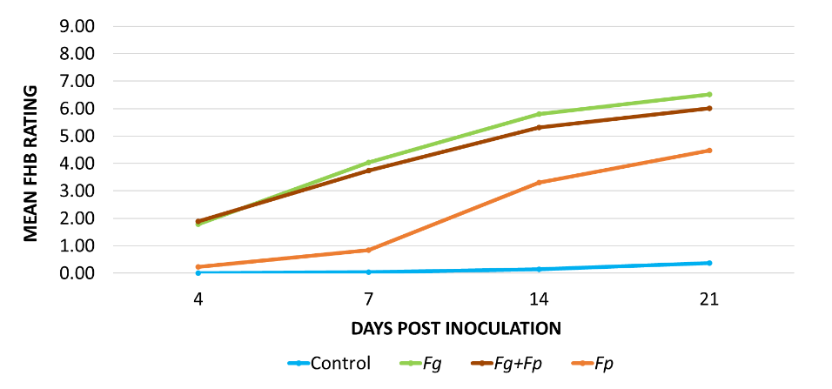

**Figure 1 - Mean disease progression per treatment, using visual disease rating scale of 0-9 (0 = no symptoms, 9 = severely diseased, spike dead); 0, no visible symptoms; 1, one diseased spikelet; 2, two diseased spikelets; 3, three diseased spikelets; 4, >3 diseased spikelets but 1/4 spike area with symptoms (sas); 5, <1/3 sas; 6, <1/2 sas; 7, <2/3 sas, slight peduncle discolouration; 8, <3/4 sas, restricted peduncle discolouration; 9, >3/4 sas, extended peduncle discolouration, spike dead. Each replication had 2 pots of each genotype for each treatment to give a total 16 pots per replication.**

**Table 1 – Two-way ANOVA for genotype and treatment effects**



**Table 2 – Pairwise comparisons between single-species, multi-species and control treatments (dpi = days post inoculation)**