**FHB Management Coordinated Project: Uniform Fungicide Trials for 2022 and 2023**

The information in this handout was authors by PIs of the USWBSI Integrated Management Coordinated Project. For the list of authors see the full publication (<https://scabusa.org/pdfs_dbupload/2023_Coordinated-Project_UFT.pdf>).

Fungicides are essential for Fusarium head blight (FHB) and deoxynivalenol (DON) management in small grain crops. However, for successful FHB control, fungicide application timing, rate, and product are all important. With emphasis on newly registered fungicides, Prosaro Pro and Sphaerex the objective of FHB management coordinated project were to compare the efficacy of Prosaro Pro (a premix of the DMIs tebuconazole and prothioconazole and the SDHI Fluopyram) and Sphaerex (a premix of metconazole and prothioconazole) to that of Prosaro, Caramba, and Miravis Ace, industry standards for FHB and DON management. To accomplish this objective, field experiments were conducted in multiple US wheat-growing states in 2023. Different fungicides programs were applied to replicated plots of susceptible cultivars, then artificially inoculated with spores of *F. graminearum*. The fungicide programs consisted of a non-treated check (CK), or an application of Prosaro (I), Caramba (II), Miravis Ace (III), Prosaro Pro (IV), or Sphaerex (V) at anthesis, or Miravis Ace at anthesis followed by an application of Prosaro Pro (VI), Sphaerex (VII), or Tebuconazole (VIII) at 4-6 days after anthesis. FHB index (IND) was assessed, and grain samples were tested for DON. Percent control (C) was estimated for IND and DON for each fungicide programs relative to CK. Mean FHB IND and DON in the checks across environments ranged from 0 to 20% and 1 to 1.2 ppm, respectively. Generally, the most effective of all tested fungicide programs were combinations of Miravis Ace followed by one of the other tested fungicides. Averaged across environments, C for IND was 99% for III, I, or II, 90% for VI, and 94% for VII. Additionally, C for DON contamination of grain was 98 and 96% for VII and VIII, respectively. The results suggest that the combination of an anthesis application of Miravis Ace followed by a “late” application of \Prosaro, Prosaro Pro, Sphaerax or Tubaconazole can be more effective at reducing FHB and DON than an anthesis-only application of any of the tested fungicides. The outcome from this study will provide stakeholders with information regarding the efficacy of the newly registered fungicides relative to the industry standards, as well as the efficacy of two-treatment fungicide programs against FHB and DON. Further analyses will be conducted to formally quantify efficacy and determine the additivity of AI mixtures and sequentially applied fungicide treatments.

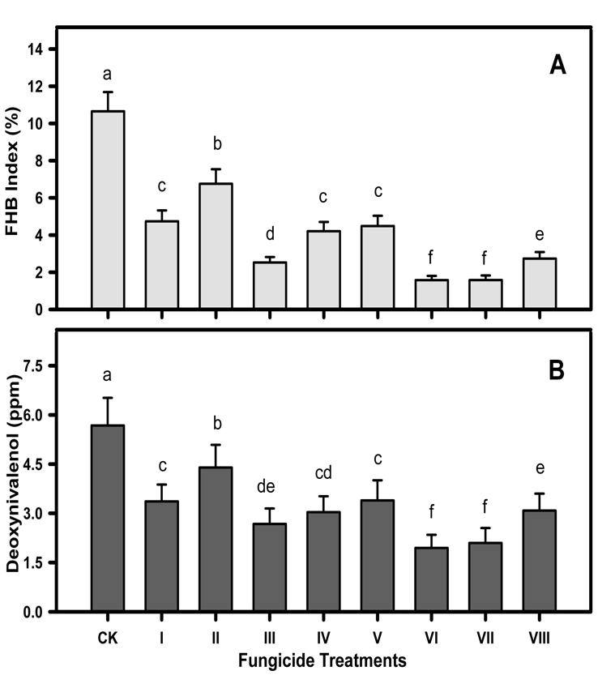

Mean **A**, Fusarium head blight index and **B**, deoxynivalenol grain contamination for different fungicide treatments for trials conducted in 2022 and 2023 growing season in different environments. **CK** = nontreated check, **I** = Prosaro (6.5 fl. oz.) applied at anthesis, **II** = Caramba (13.5 fl. oz.) applied at anthesis, **III** = Miravis Ace (13.7 fl. oz.) applied at anthesis, **IV** = Prosaro Pro (10.3 fl. oz.) applied at anthesis, **V** = Sphaerex (7.3 fl. oz.) applied at anthesis, **VI** = Miravis Ace applied at anthesis followed by Prosaro Pro 4-6 days later, **VII** = Miravis Ace applied at anthesis followed by Sphaerex 4-6 days later, and **VIII** = Miravis Ace applied at anthesis followed by Tebuconazole (4 fl. oz) 4-6 days later. For FHB index, each bar in **A** represents the mean across 21 trials, whereas for DON, each bar in **B** represents the mean across 20 trials. Errors bars are standard errors of the mean. Models were fitted and means were compared on the arcsine square root-transformed scale for IND and log-transformed sale for DON, with fungicide treatments as a fixed effect. Graphs are shown on the raw data scale for convenience.