**FHB Management Coordinated Project: Integrated Management Trials 2022-2023**

The information in this handout was authors by PIs of the USWBSI Integrated Management Coordinated Project. For the list of authors see the full publication (<https://scabusa.org/pdfs_dbupload/Report-2023_USWBSI_Uniform-IM-Studies.pdf>).

Integrated approaches for managing Fusarium head blight (FHB) and deoxynivalenol (DON) contamination of grain include agronomic practices, resistant cultivars, and chemical control. Prothioconazole, metconazole, and tebuconazole are three of the most effective demethylation inhibitors (DMI) fungicide active ingredients (AIs) for FHB and DON control. While the efficacy of Prosaro (a premix of the DMI  AIs tebuconazole and prothioconazole) and Miravis® Ace (a premix of the DMI Propiconazole and the SDHI Pydiflumetofen), industry standards for FHB and DON management,  has been well documented, it is informative to determine whether newly labeled products such as Prosaro Pro (a premix of the DMI tebuconazole and prothioconazole and the SDHI Fluopyram) and Spaherax (a premix of metconazole and prothioconazole) will be just as or more effective than the industry standards when used in combination with cultivar resistance. Therefore, the overall objective of the study was to determine the efficacy of these new fungicides when used alone or as part of integrated management programs. To accomplish this objective, field experiments were conducted in several US wheat-growing states during 2023 wheat growing season. Separate replicated plots of susceptible (S), moderately susceptible (MS), or moderately resistant (MR) cultivars were treated with Prosaro, Miravis Ace, Prosaro Pro, or Sphaerex at Feekes 10.5.1 or left untreated, and subsequently inoculated with spores of *Fusarium graminearum*. Percent control (C) was estimated for FHB index (IND) and DON for each cultivar x fungicide program combination relative to the non-treated susceptible check (S_CK). Mean IND and DON in S_CK ranged from 0 to 74% and 0 to 3.2 ppm, respectively. Averaged across environments, combination of MR cultivars and fungicide treatments showed higher C for IND and DON than treatments applied to S cultivars.  For instance, across the tested fungicide programs, C for IND ranged from 88 to 94% on MR and 82 to 92 % on MS cultivars, compared to 82 to 89% on S cultivars. Additionally, C for Miravis Ace, Prosaro, Prosaro Pro and Sphaerex combination with cultivar resistance ranged between 89 to 94% for MR and 82-92% for MS. Preliminary finding from this study will provide stakeholders with useful information regarding the efficacy of the new fungicide mixtures relative to the industry standards when used as part of integrated management programs to control FHB and DON.

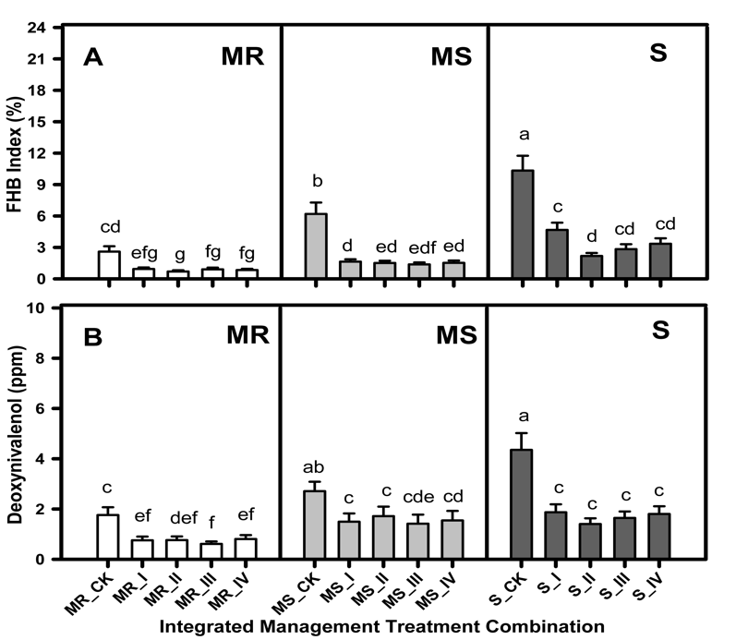

Arithmetic mean **A**, Fusarium head blight index (IND) and **B**, deoxynivalenol (DON) grain contamination for different fungicide program x cultivar resistance management combinations. **S**, **MS**, and **MR** represent susceptible, moderately susceptible, and moderately resistant, respectively, whereas **CK** = nontreated check, **I** = treated with Prosaro (6.5 fl. Oz.) at anthesis, **II** = treated with Miravis Ace (13.7 fl. Oz.) at anthesis, **III** = treated with Prosaro Pro (10.3 fl. Oz.) at anthesis, and **IV** = treated with Sphaerex (7.3 fl. Oz.) at anthesis. Each bar in A and B shows the mean response averaged across 16 and 9 trials from the 2022 and 2023 growing season, respectively. Errors bars are standard errors of the mean. Models were fitted and means were compared on the arcsine square root-transformed scale for IND and log-transformed scale for DON. Graphs are shown on the raw data scale for convenience.